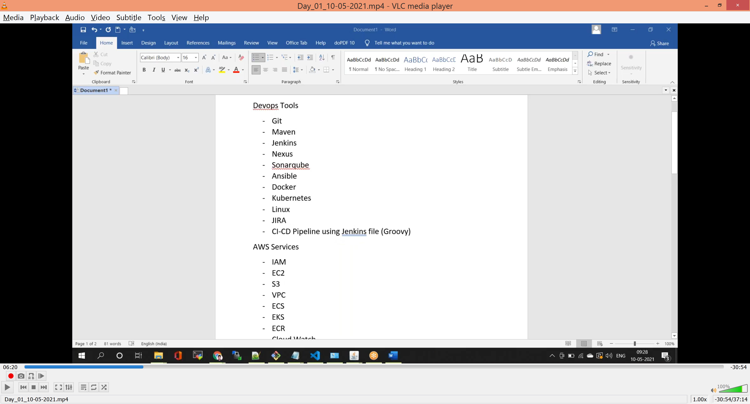

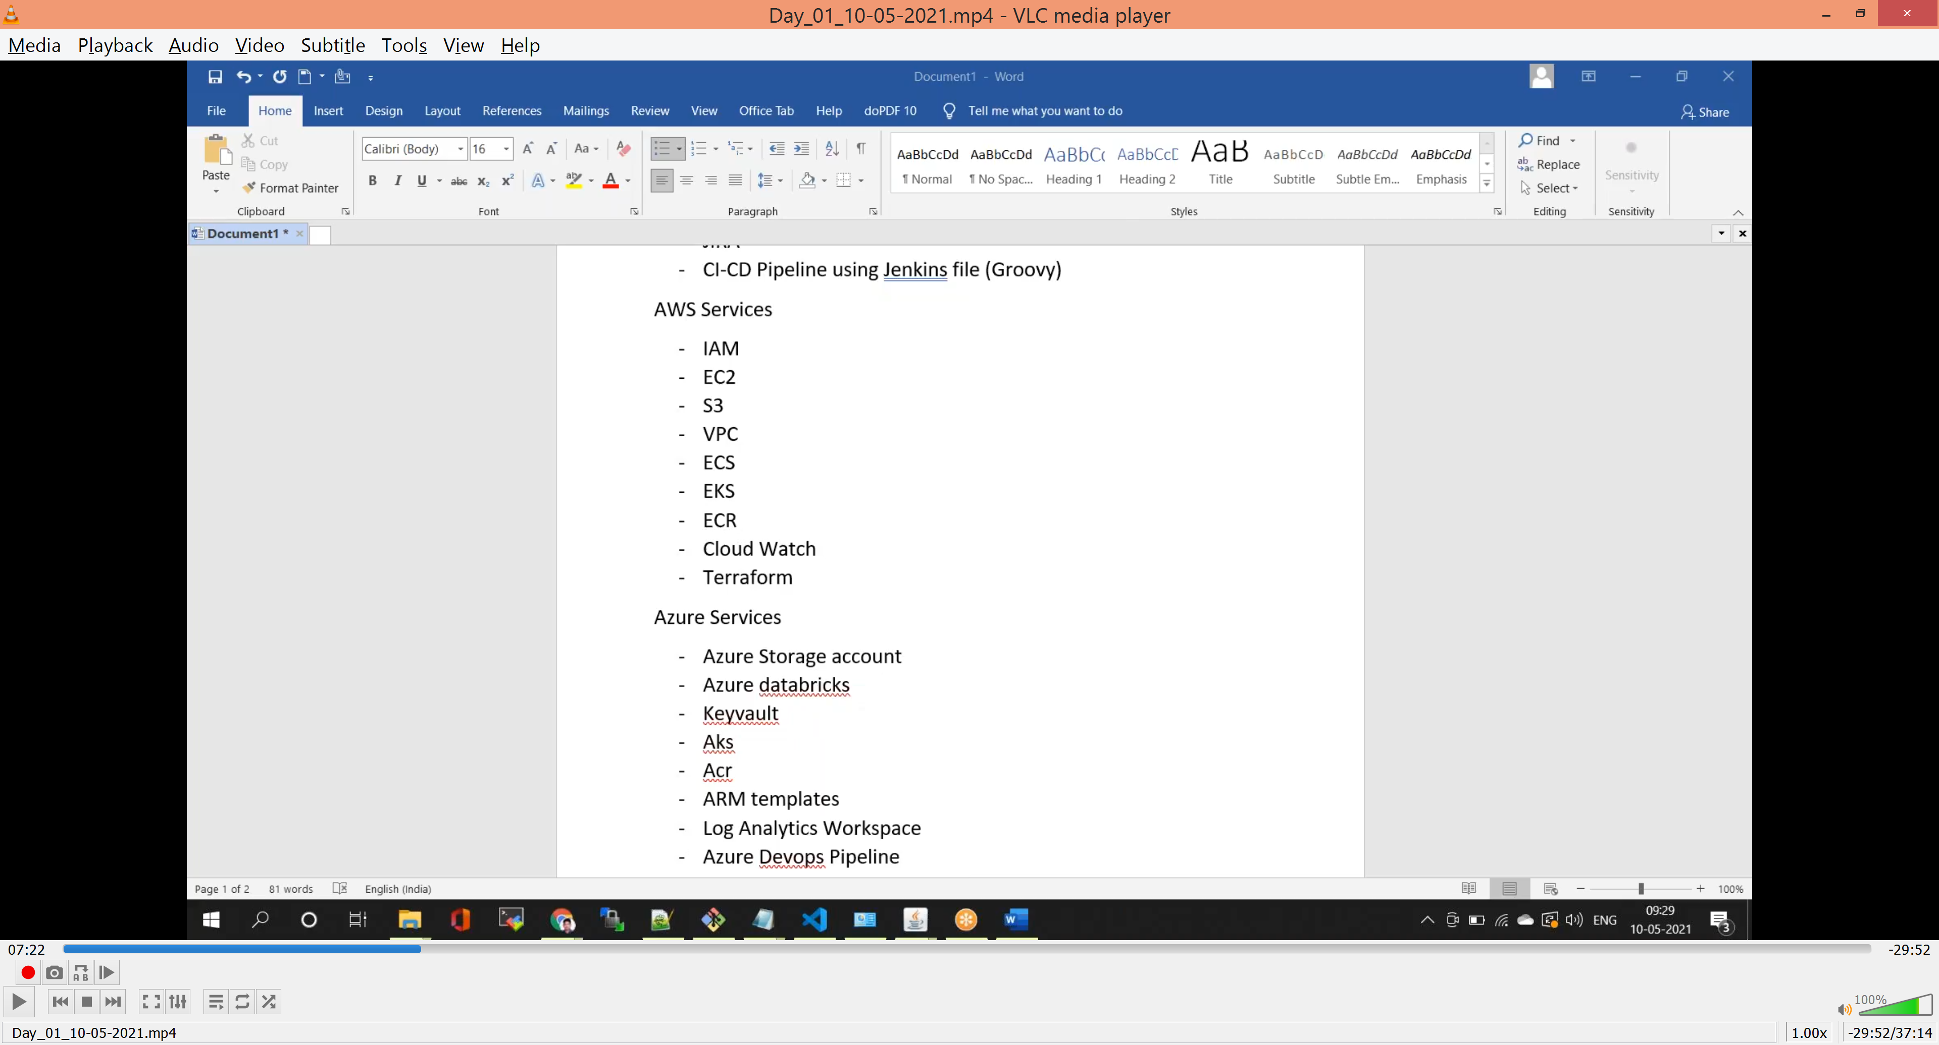

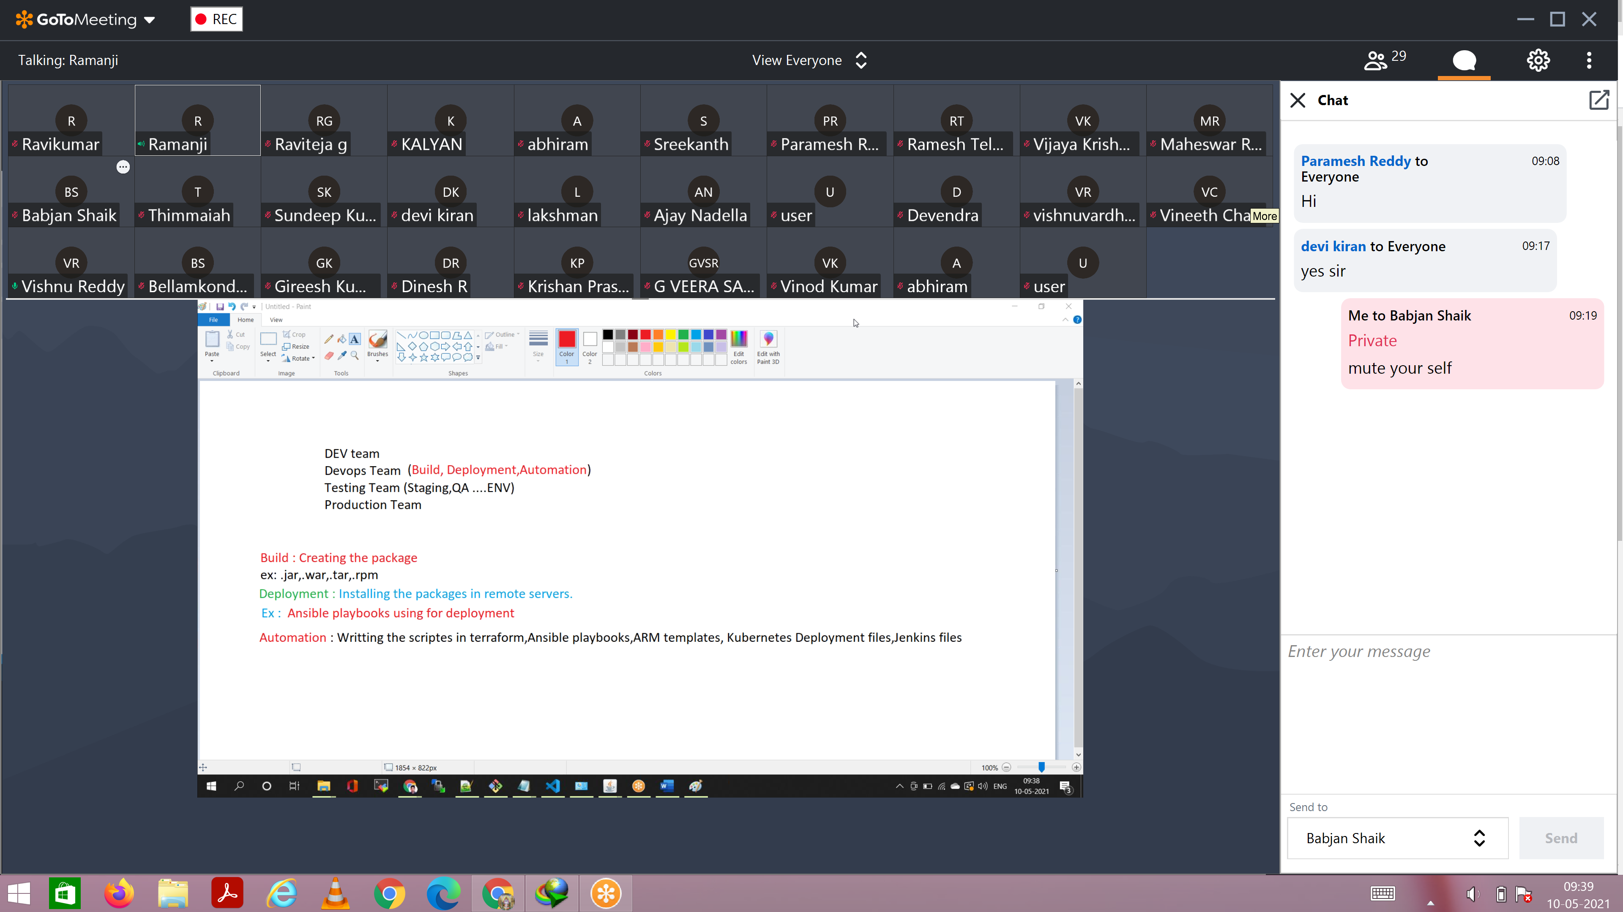

Build:-

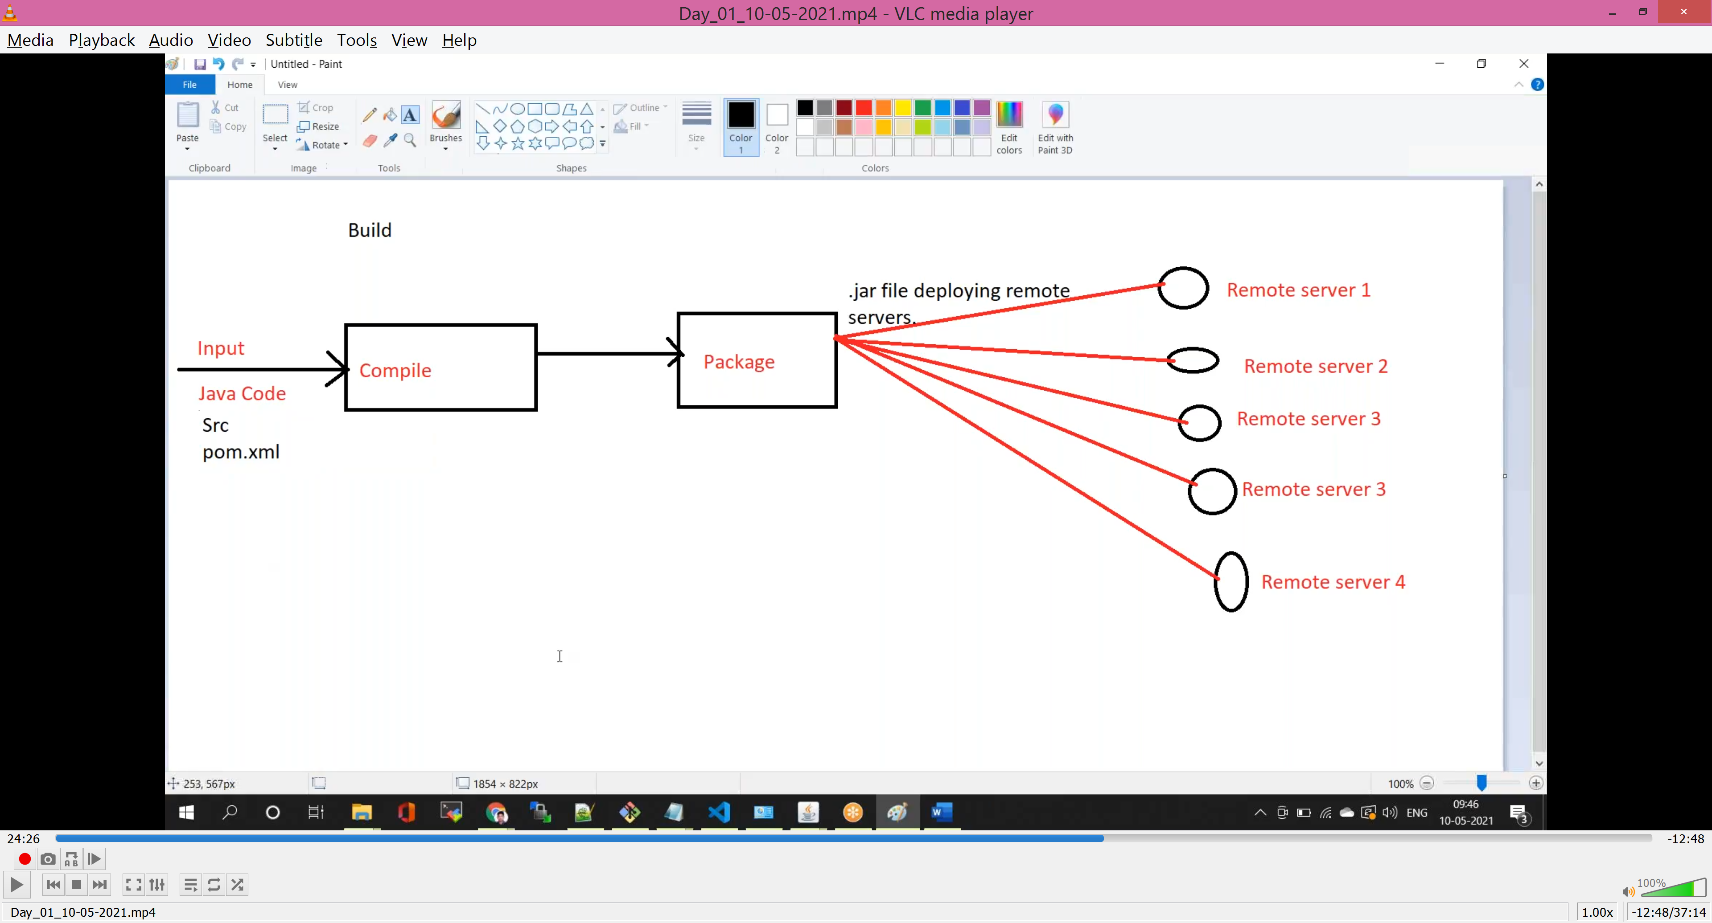

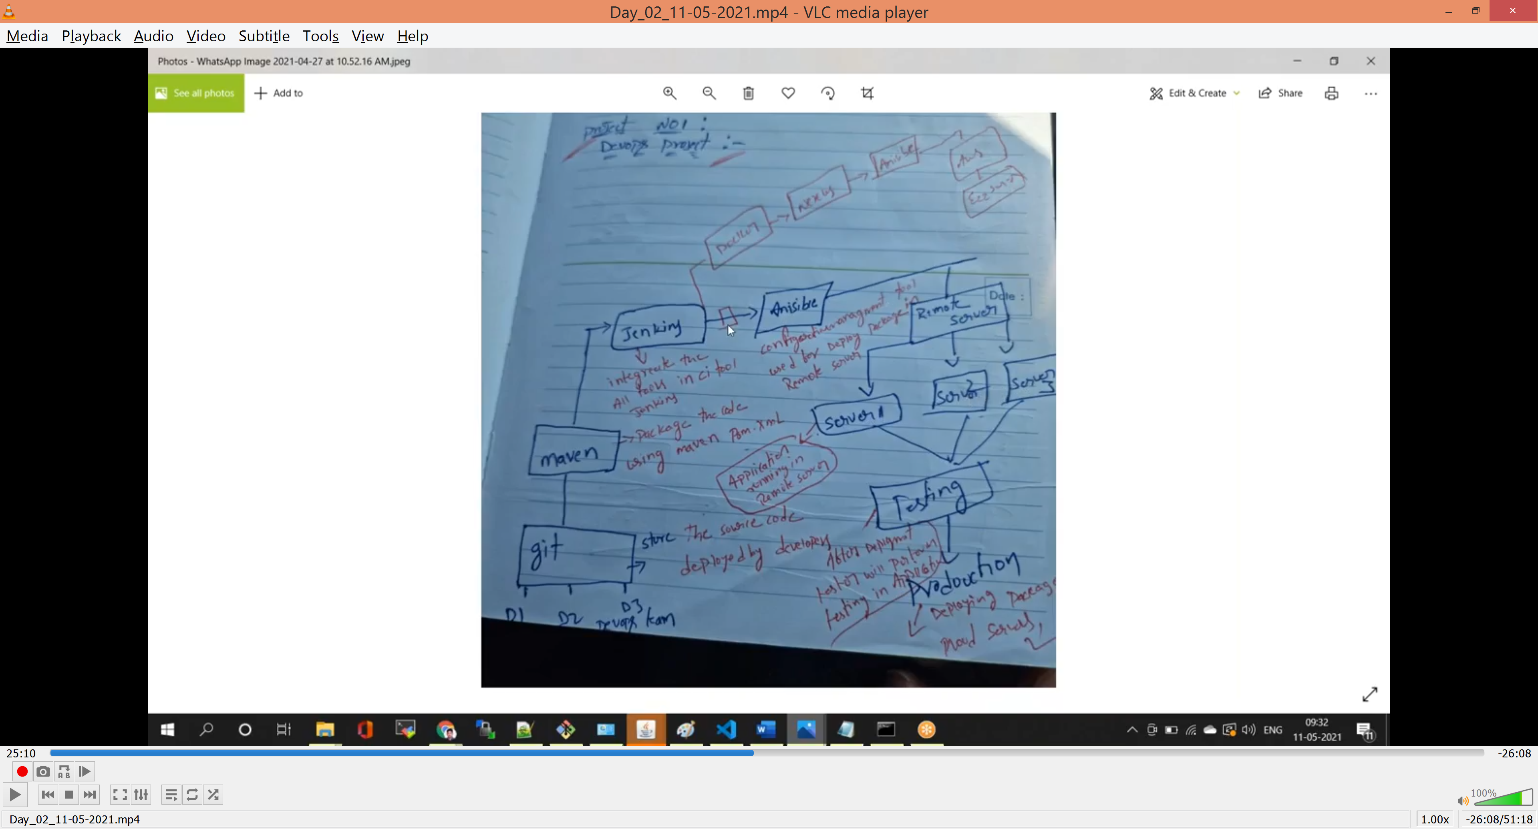

Configuration App:-

Puppet

Chef

Anisible

Rundeck

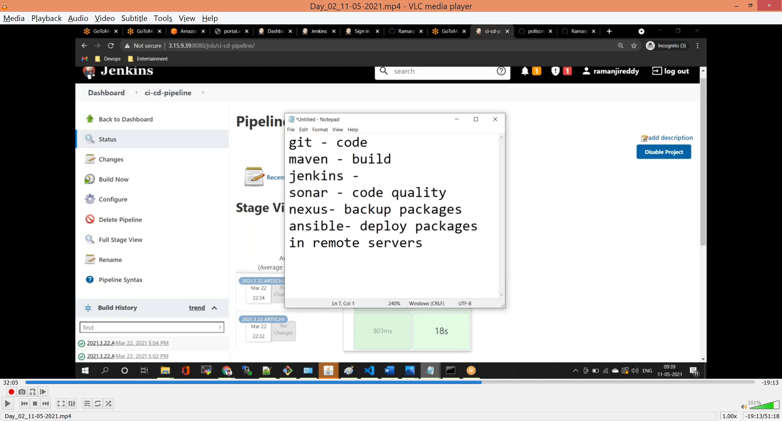

Git Commmands

- git clone <repositoryname> 'to clone the remote repository name

- git status 'to check untracked files status

- git add 'to add the untracked files

- git log 'to check history of logs

- git diff 'to see difference between two changes

- git checkout -b <newbranchname> 'to create the new branch in git

- git branch 'to check the list of branches

- git delete origin <branch name> 'to delete remote branch

- git commit –m “<Message>” ‘to commit the changes

- git push origin master ‘push the changes from local to remote repository

- git merge

- git pull

- git fetch

- git pull request

- git reset

- git revert

- git stash

**- git reset vs git revert

Git revert – using for undo the specific change

Git reset – used for return the entire tree or entire branch to the last committed state

**-git pull vs git fetch

Git fetch is the command that says “bring my local copy of the remote repository up to date.”

Git pull says “bring the changes in the remote repository to where I keep my own code.”

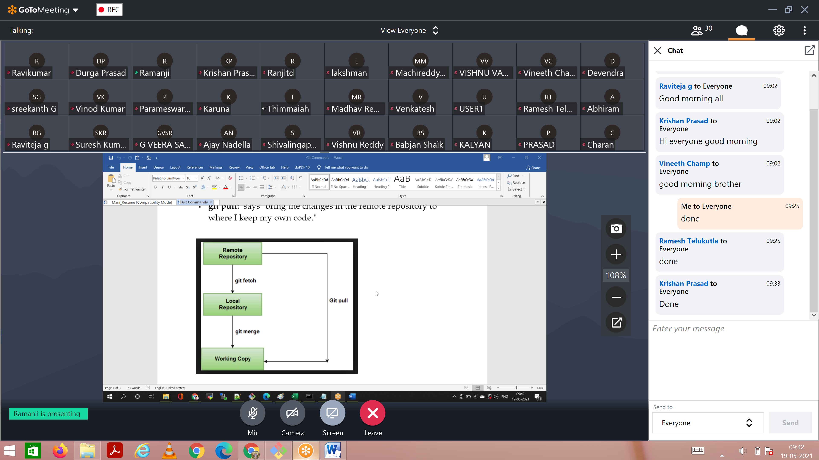

Git Pull = Git Fetch + Git Merge

**What is git webhooks?

Webhooks used to schedule the activity/build job in jenkins

Git Repository

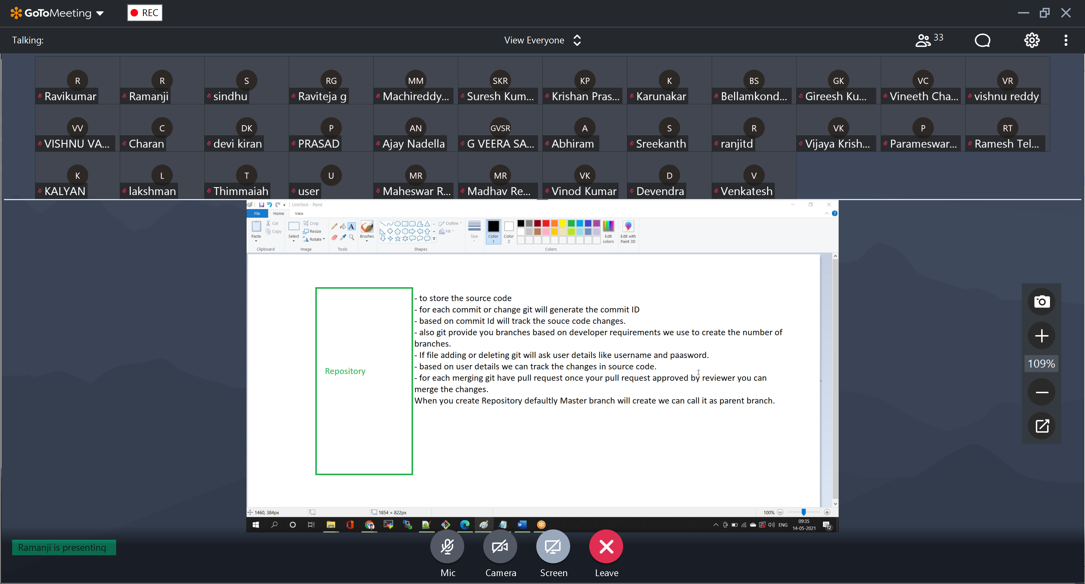

Build/Packaging

Maven (Build Tool)

Build tool using maven we are package the source code

Build: Creating the package

Package: collection of .class files

.classfiles: After compile the java code output is .class files

Package ex: .jar, .wwar, .tar, .rpmm, .ear

Interview Questions

Which architecture / which registry you are using

Nexus (to store .jar, .war, .tar, docker images) / Docker Hub (for only docker images)

What type of EC2 servers you are using?

For different environments different size servers we are using, its completely based on the business requirement.

Explain Git Branching Strategy

Or

Can you explain how you people are maintaining git branches

What is meant by branch and why required

Based on Situation developer will create branches

Development (enhancements to existing app/code)

Naming convention Ex (dev1.6-coles-17-05-21)

Release (testing developed code)

Naming convention Ex (dev1.6-coles-17-05-21)

Bug fixing (if any bugs occur for existing code)

Naming convention Ex (dev1.6.0-coles-17-05-21)

Naming convention Ex (dev1.6.1-coles-17-05-21)

Naming convention Ex (dev1.7.1-coles-20-05-21)

Dev branch

Definition: - When we are going to add new functionality in my application then we will create development branch

Example: - Dev1.0, Dev1.1, Dev1.2., etc

Release Branch

Definition: - Once development is completed the code will go to testing phase, after testing completed then we will create release branch

Example: - Rel-Dev1.0-7-5-21, Rel-Dev1.1-7-10-21, Rel-Dev1.2-15-10-21

Bug fix Branch

Definition:- After release is completed then in case any issue happened on existing releases then we are creating bug fix branches

Example: - Bugfix_Dev1.0.1_7-5-21, Bugfix_Dev1.1.1_7-10-21

Merge conflicts:

